**Q. C prog to implement Simpson’s 1/3 rule**.

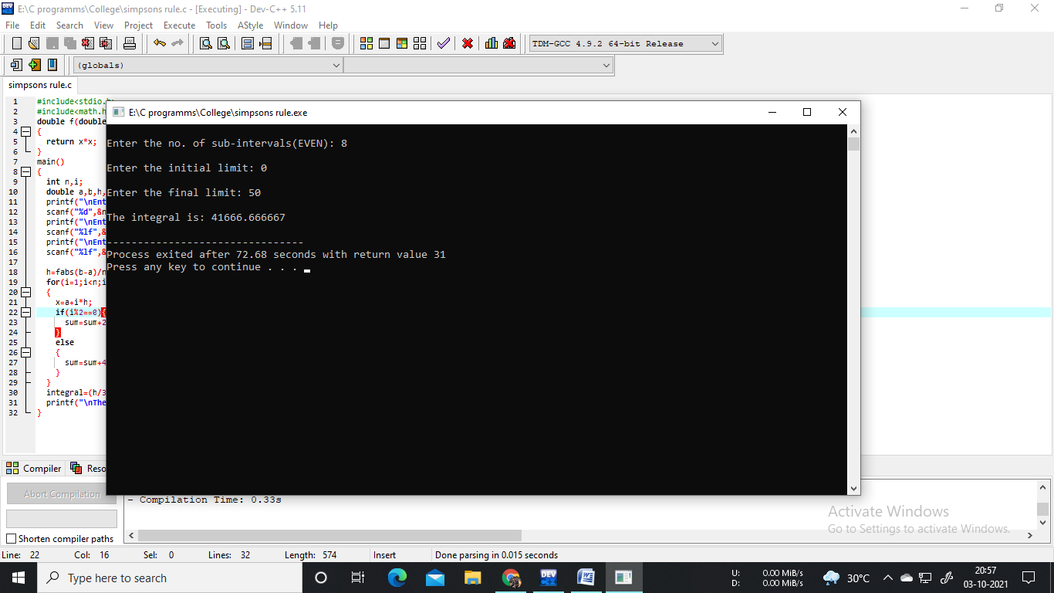#include<stdio.h>

#include<math.h>

double f(double x)

{

return x*x;

}

main()

{

int n,i;

double a,b,h,x,sum=0,integral;

printf("\nEnter the no. of sub-intervals(EVEN): ");

scanf("%d",&n);

printf("\nEnter the initial limit: ");

scanf("%lf",&a);

printf("\nEnter the final limit: ");

scanf("%lf",&b);

h=fabs(b-a)/n;

for(i=1;i<n;i++)

{

x=a+i*h;

if(i%2==0){

sum=sum+2*f(x);

}

else

{

sum=sum+4*f(x);

}

}

integral=(h/3)*(f(a)+f(b)+sum);

printf("\nThe integral is: %lf\n",integral);

}